**ASSIGNMENT-1.2**

**LINUX COMMANDS SCREENSHOTS WITH OUTPUT:**

1. **Pwd –** This command helps to know the current working directory

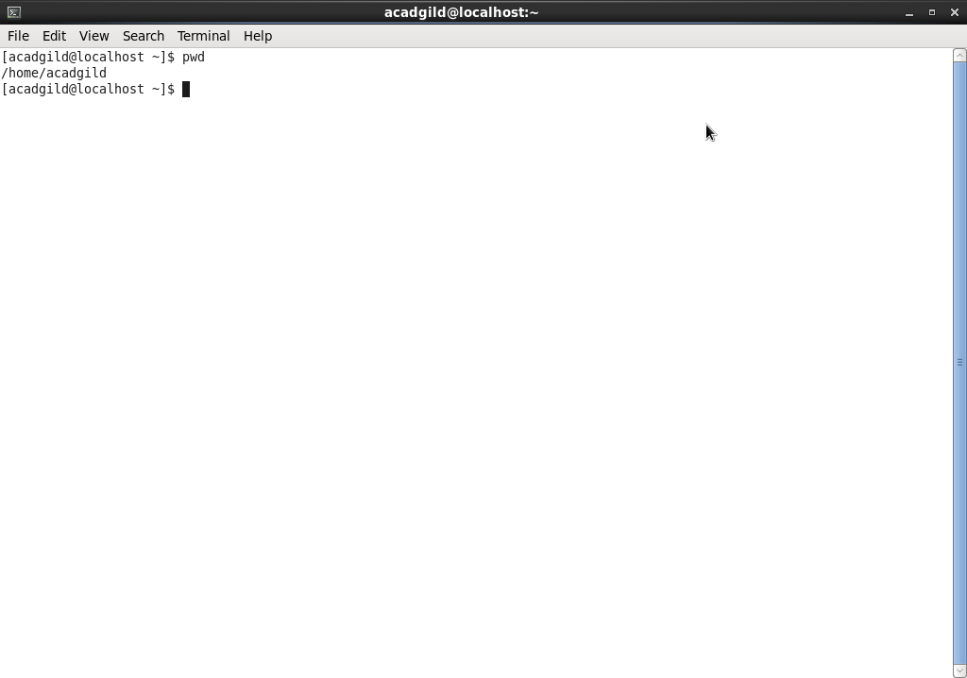

1. **Vi –** This command is used to create a file

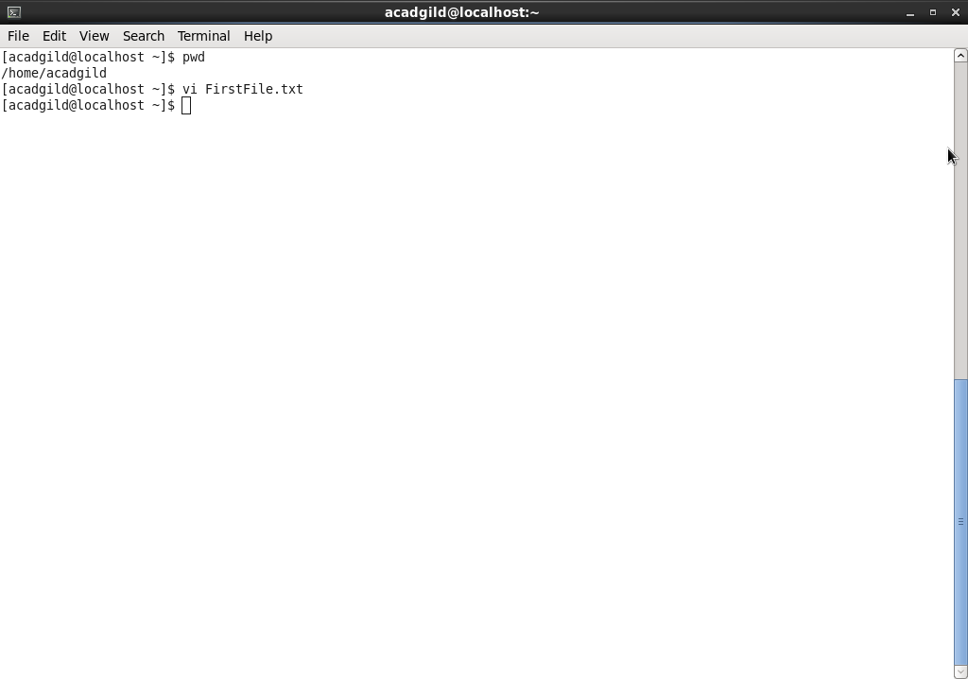

**Output of vi command file contents: (FirstFile.txt is created)**

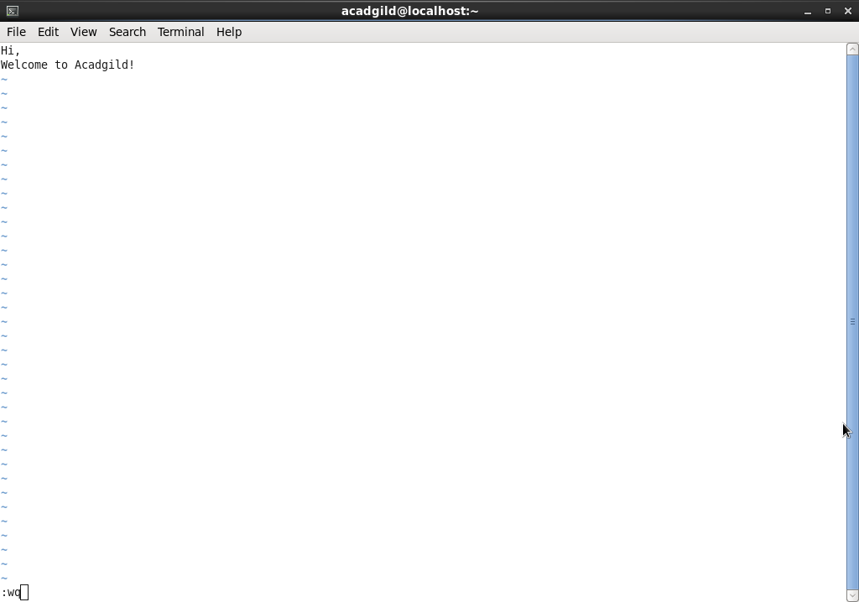

1. **Touch –** This command helps to create multiple files in one go.

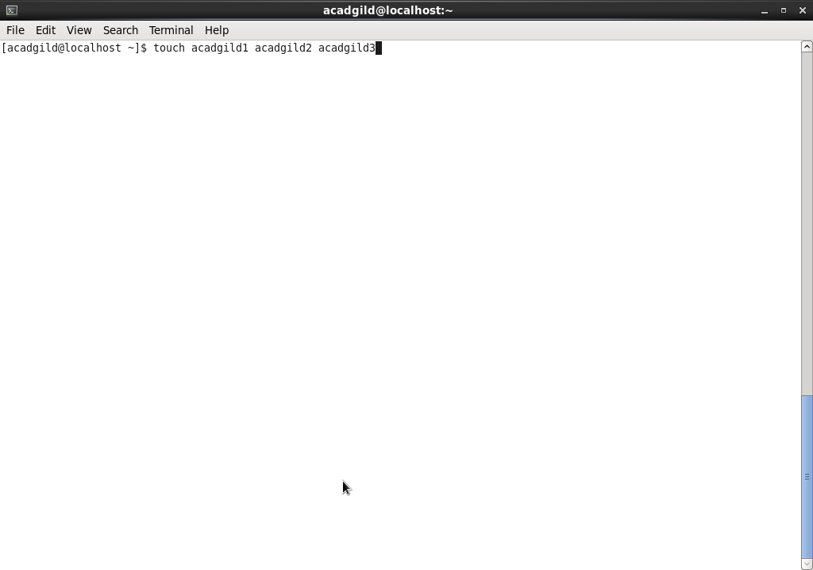

**Output of Touch Command: (Files acadgild1,acadgild2,acadgild3 created via touch command)**

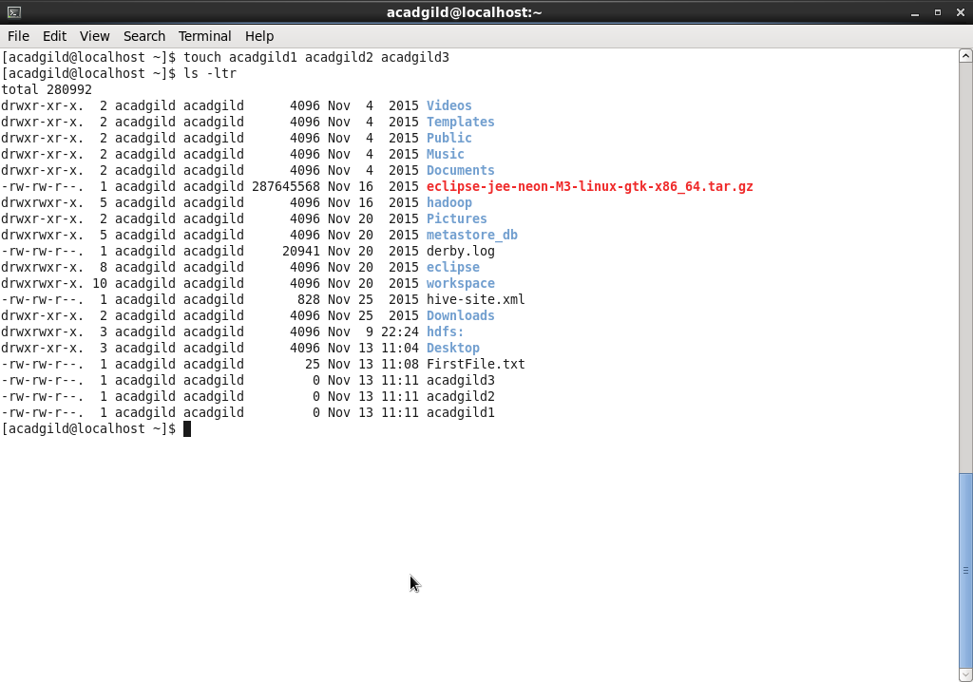

1. **Mkdir –** Creadtes a directory

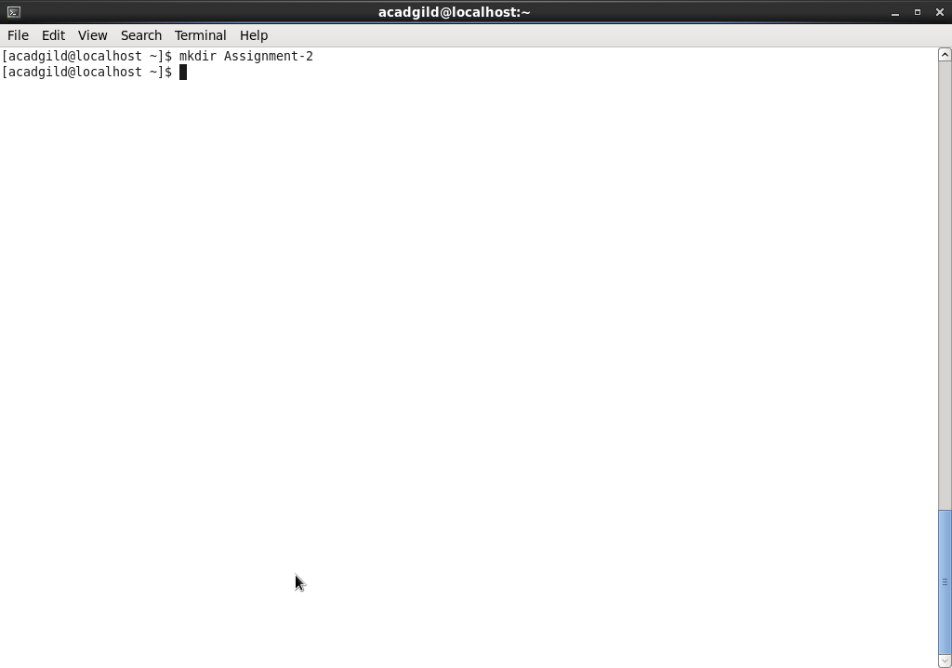

**Output of mkdir command: (Assignment-2 directory created)**

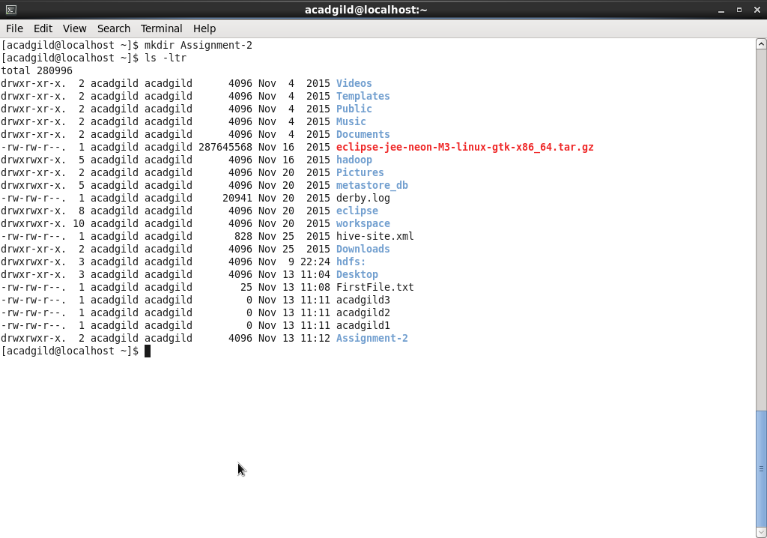

1. **Rm –** Removes a particular file or directory

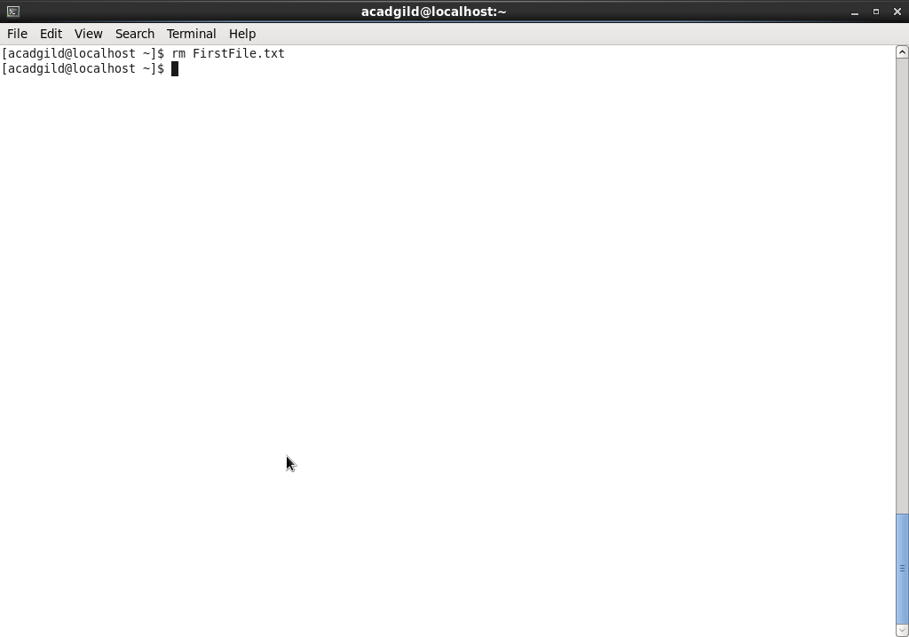

**Output of rm command: (FirstFile.txt created via vi command will not exist as it is now removed by rm command)**

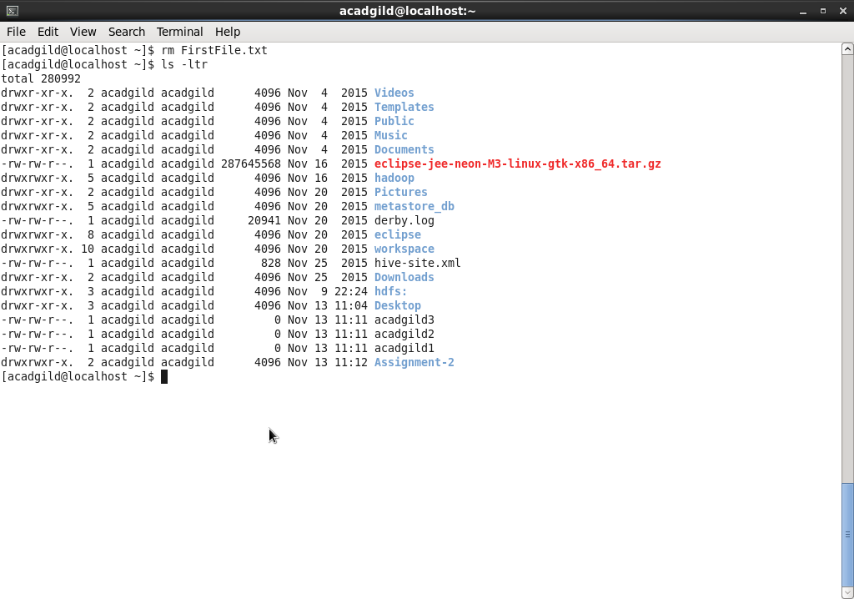

1. **Ls –** Lists all the directories and files

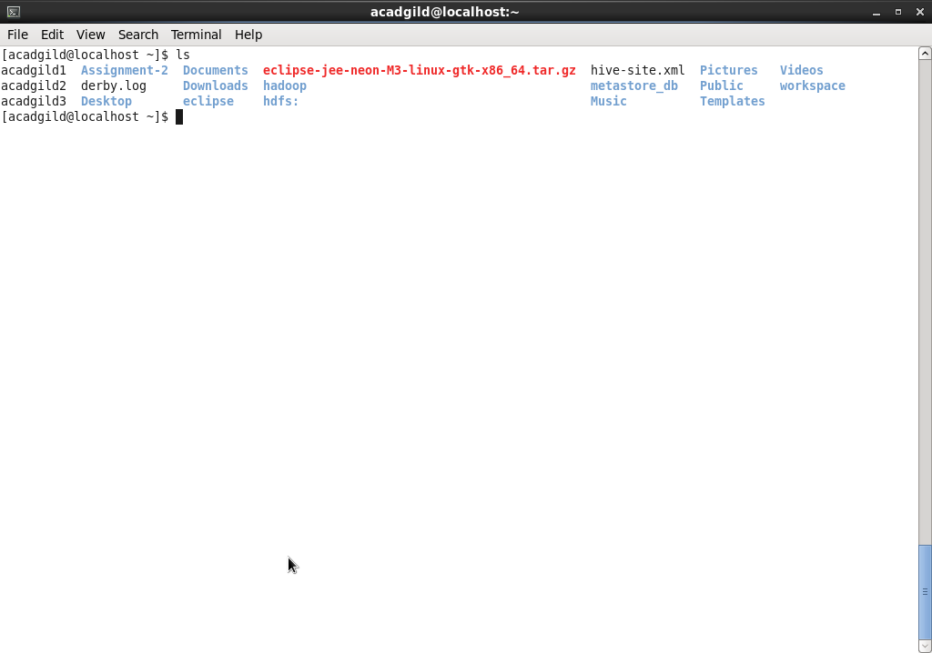

1. **Echo –** This command helps to determine the path and append the contents typed on screen to the file.

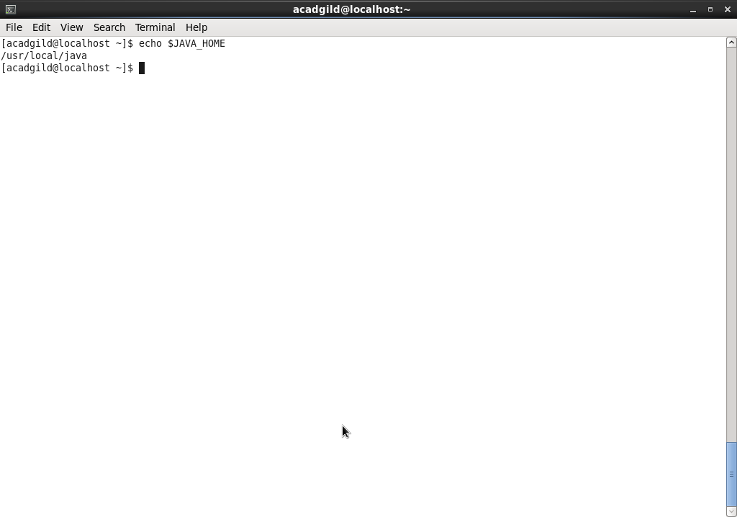

1. **Cat –** This command prints the contents of file on screen.

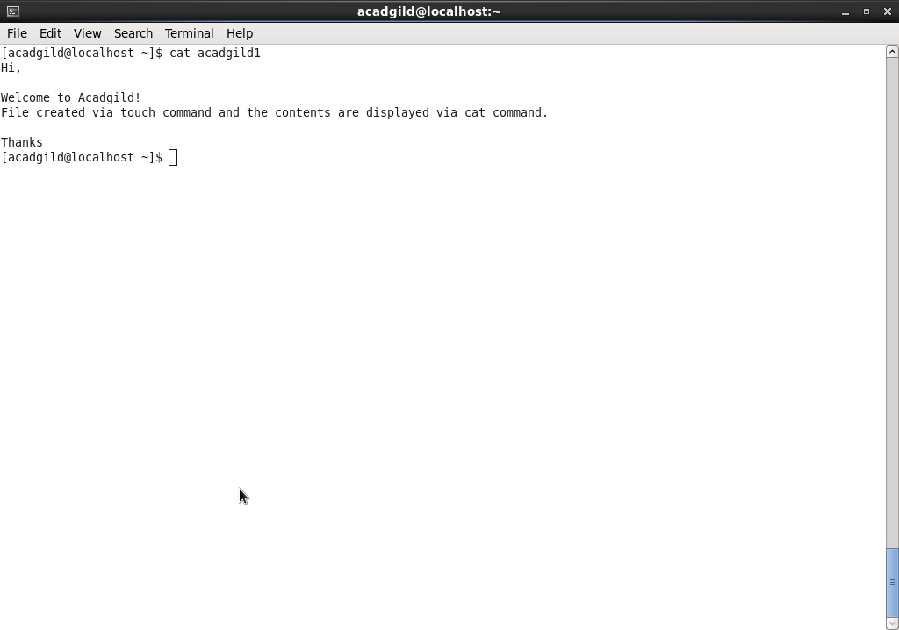

1. **Who –** This command shows the name of current user.

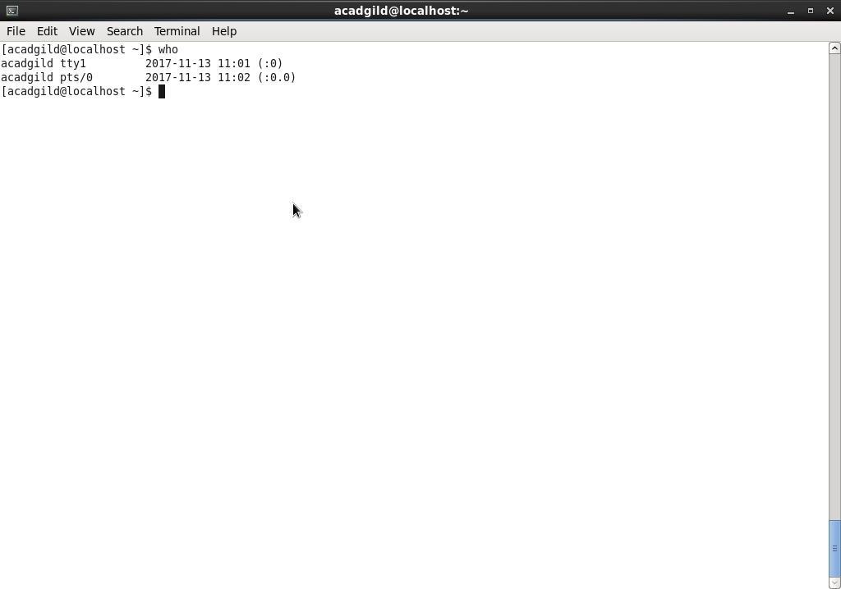

1. **Cd –** This command helps to change directory

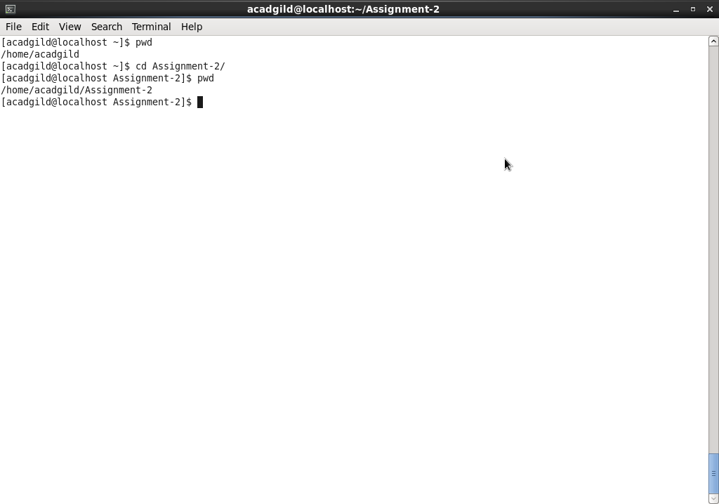

1. **Date –** This shows the current date and also helps us identify the date of next Monday.

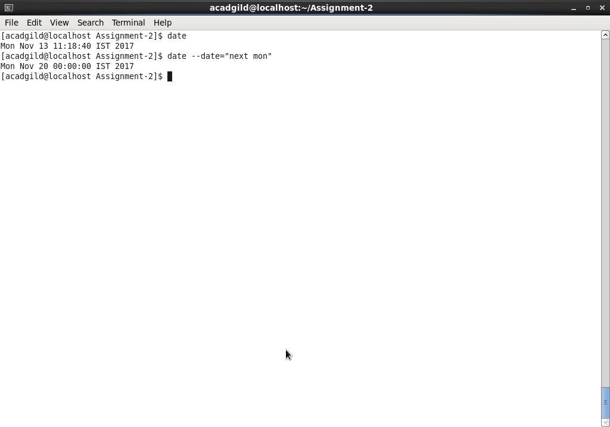

1. **Cal –** cal command shows the calendar month,week and year depending on the calendar options passed

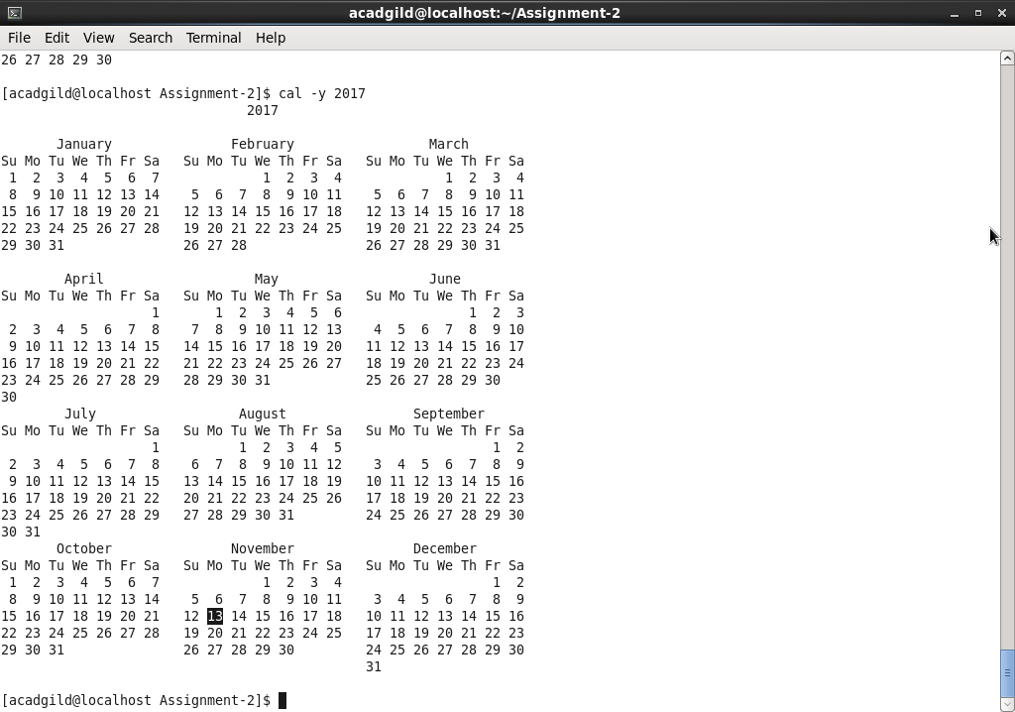

1. **Mv –** This command moves the file from one path to other. Here the file acadgild2 is moved to Assignment-2 Directory.

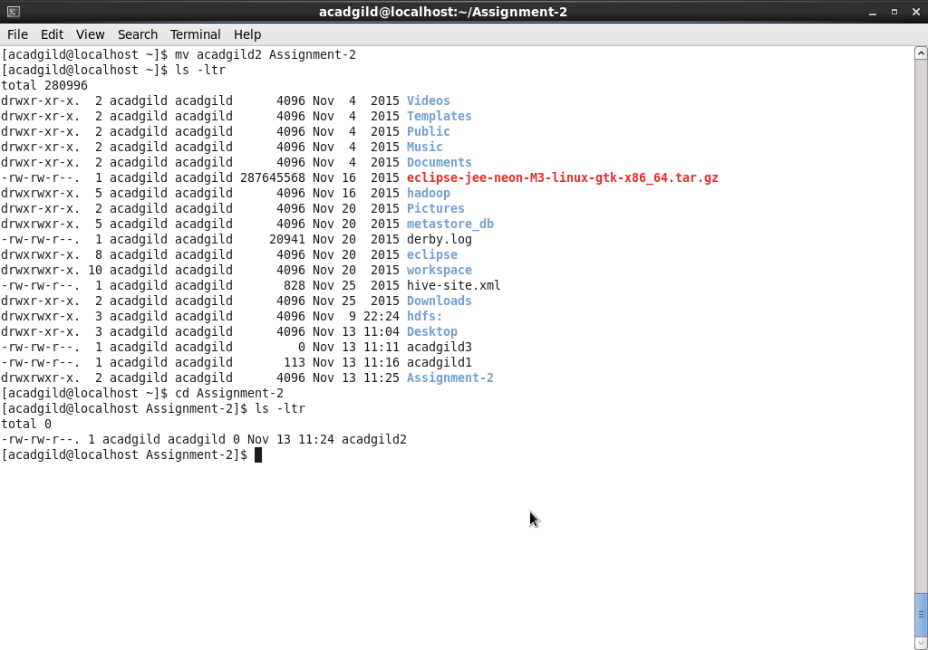

1. **Cp –** This command copies the contents of one file to other file. Acadgild3 file has size 0 initially and on doing cp command, the contents of acadgild1 are copied to acadgild3 and the size of acadgild3 file becomes 113B.

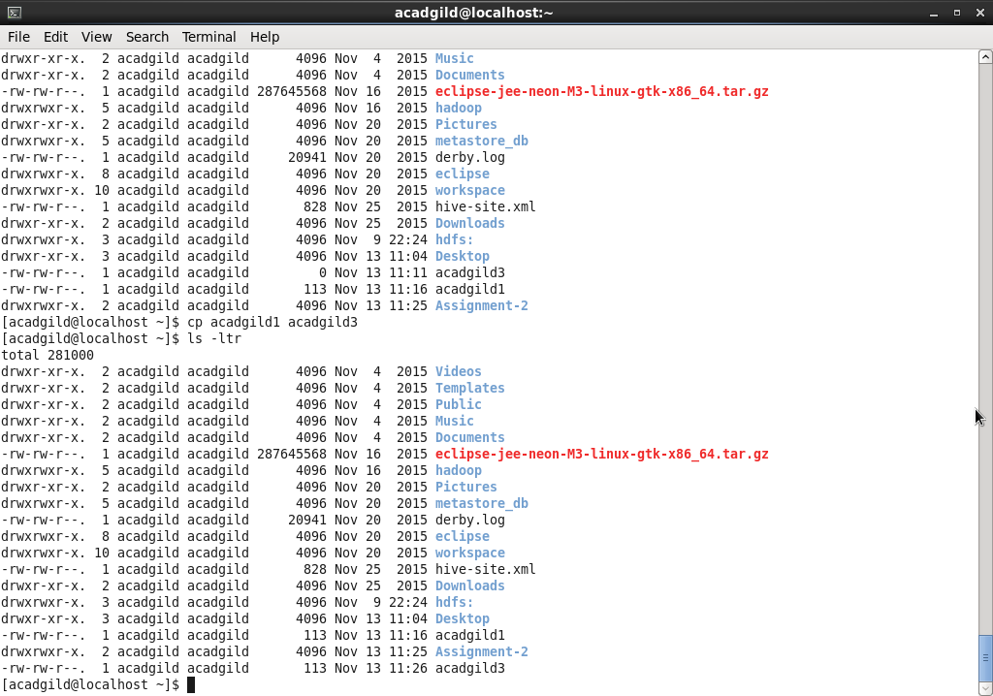

1. **Which –** This command shows the location/path of folder.

